# Angular

**Materials and resources:**

<https://angular.io/docs>

<https://cli.angular.io/>

<https://www.dunebook.com/from-zero-to-hero-learn-angularstrap-from-scratch/>

<http://www.netinstructions.com/100-days-of-angular-2/?utm_source=mybridge&utm_medium=web&utm_campaign=read_more>

<https://github.com/johnpapa/angular-styleguide/blob/master/a2/README.md>

<https://legacy.gitbook.com/book/basarat/typescript/details>

<https://basarat.gitbooks.io/typescript/>

<https://www.youtube.com/watch?v=qRD7bkK7m10>

<https://thinkster.io/tutorials/learn-angular-2>

<https://www.tutorialspoint.com/angular2/>

Books: ng-book2-r37

**Assignments:**

‘ChinaBay’ is a big company that is selling a different type of products. They decide to make E-commerce site in order to be able to sell their products online. They hire your team to make their E-commerce site.

The e-commerce site has ‘Portal’ panel where users can view and buy the products and ‘Admin’ panel where admins can manage categories and products.

### 1 Task: Set-up Angular project

### 2 Task: Implement admin layout.

Implement basic layout, page structure, Menu, Navbar, logo etc. Page should be responsive and design is up to you.

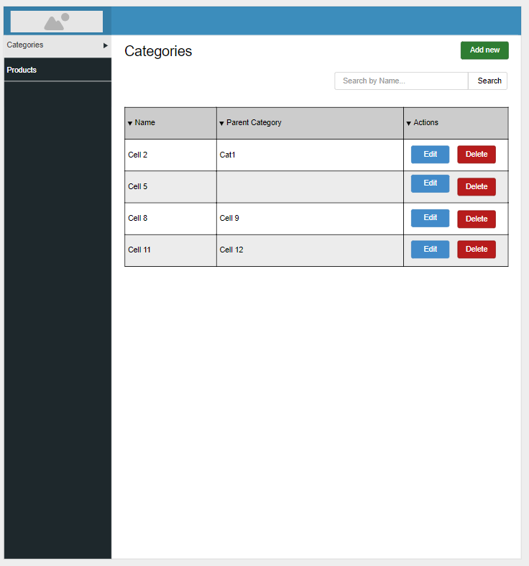

### 3 Task: Implement Category List page

Admin panel is a section where Admin users can manage ‘Product’ and ‘Categories’.

1.1 Categories

Every product has at least one category and every category can have a parent category. Admin users manage categories from the admin panel, they can:

- An Admin user can view a list of all categories and search the categories.

- An Admin user can add a category

- An Admin user can edit category

- An Admin user can delete a category

1.1.1 List categories

All categories in the system are listed in table same as the following mockup. On top of the table, there is a search field that is searching categories by name. When the user enters some word in the input search bar and clicks ‘Search’ only categories that contain word entered in the input field are displayed in the table.

1.1.2 Delete category

When a user clicks on delete button on the same category confirm dialog is open with a text ‘Are you sure you want to perform this action?’ and two buttons ‘Yes’ and ‘Cancel’. When user select ‘Yes’ button category is deleted and removed from the table.

**